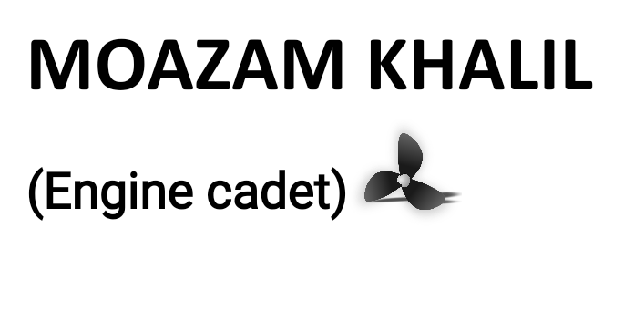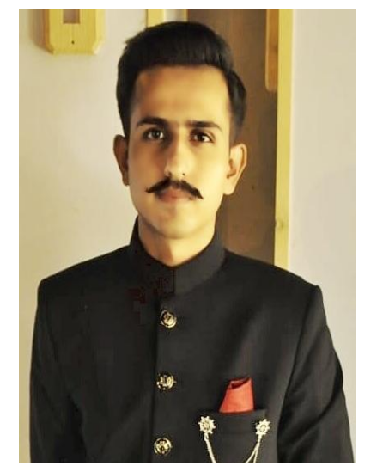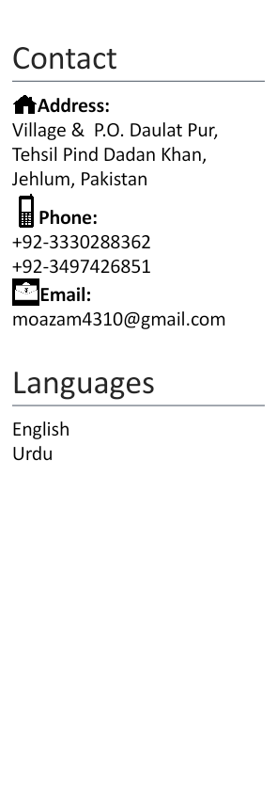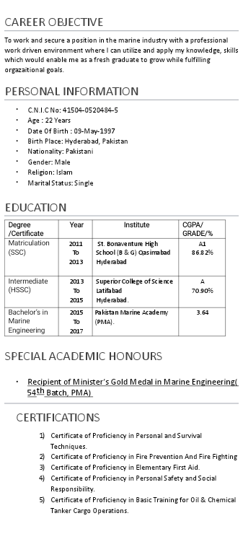

WORKSHOP AND ADDITIONAL COURSES ATTENDED

* Attended Workshop at Pakistan National Shipping Corporation (PNSC) from July 16th 2018 to July 15th 2019 (1 year).
* Certificate in Boiler Operation & Maintenance from 8th July,2018 to 7th October ,2018.

PERSONAL TRAITS

* Adaptable and flexible
* Able to work under pressure.
* Ability to detect faults.
* Good written and communication skills..
* Well organized and detail oriented.
* Detecting operating errors and correcting accordingly.
* Excellent training skills.
* Excellent management skills.

PROFESSIONAL EXPERIENCE  
  
Working as Trainee Marine engineer in Port Qasim Authority(PQA) since 11th Sept,2019 -till date.